Title: NANO NAVIGATOR

Mentor Name: Stephen Sagayaraj. A

Team Members Name: Gowtham. T
Ajay. A
Suthan. S
Manoj. R
Dhiva.R
Institute Name: Bannari Amman Institution of Technology
Corresponding mail id: Stephensagayaraja@bitsathy.ac.in

ABSTRACT
Robotics has long struggled with the maze-solving problem, especially in autonomous navigation. Research on decision-making algorithms that allow robots to negotiate challenging settings is still crucial. This project uses a specially designed Printed Circuit Board (PCB) and the STM32 microcontroller to construct and develop an autonomous maze-solving robot. The robot solves labyrinth structures effectively by using two well-known maze-solving algorithms: the Wall Following method and the Flood Fill algorithm.
The robot can avoid collisions and move through the maze on its own thanks to Time-of-Flight (TOF) sensors, which provide precise wall identification. The PCB design, which incorporates the required parts for control, sensor interface, and power management, is part of the hardware development process. Both maze-solving algorithms, which direct the robot's decision-making while it navigates the maze, are implemented as part of the software development. Furthermore, a strong collision-avoidance system built on TOF sensors guarantees uninterrupted, trouble-free robot operation.
The robot's ability to traverse and solve the maze effectively was confirmed by testing its performance in a variety of maze designs. In order to effectively reach the goal while avoiding walls and other obstacles, the system showed a high degree of reliability. This research demonstrates the potential uses of hardware and software integration in robotics and autonomous systems by constructing an effective autonomous maze-solving robot.
KEYWORDS: Autonomous Navigation, Maze Solving, Flood Fill, WallFollowing, STM32, PCB.

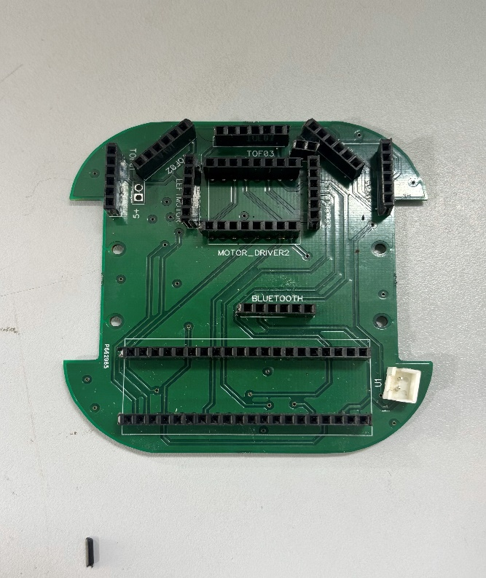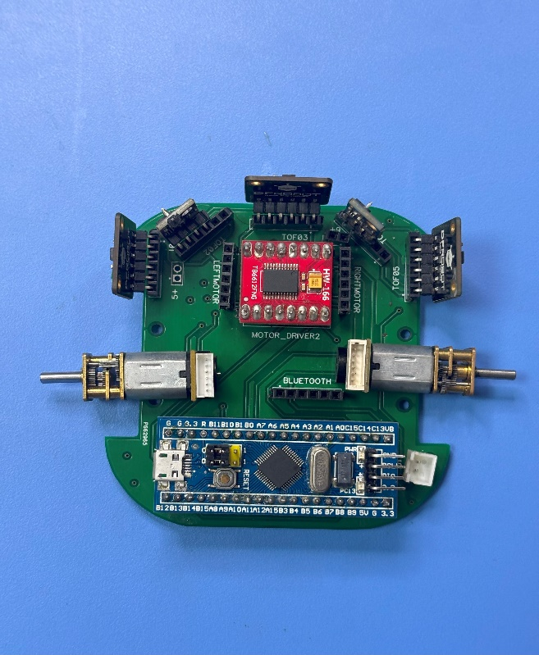
Figure 1: PCB Overview Figure 2: Accembled Overview

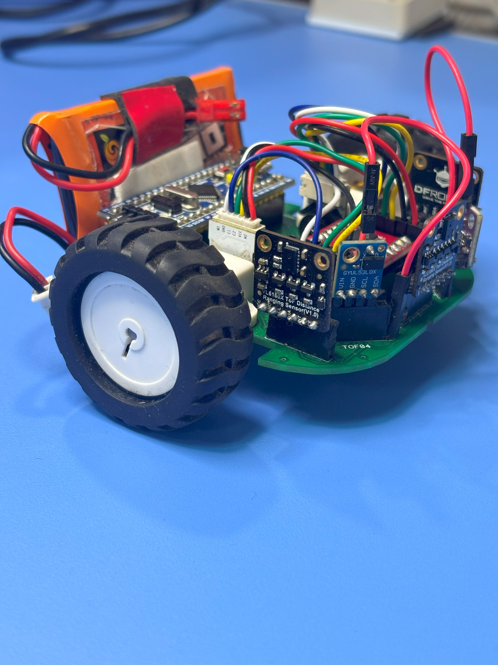 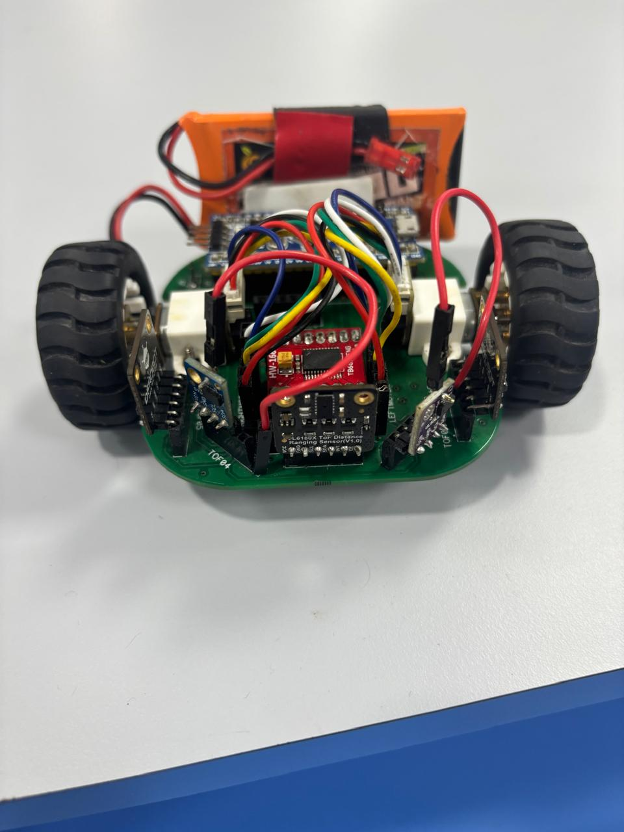
Figure 3: Fully Accembled Robot Figure 4: Fully Accembled Robot

